P.G. & RESEARCH DEPARTMENT OF MICROBIOLOGY
JAMAL MOHAMED COLLEGE (Autonomous)
Accredited (3rd Cycle) with ‘A’ Grade by NAAC
(Affiliated to Bharathidasan University)
TIRUCHIRAPPALLI – 620 020.

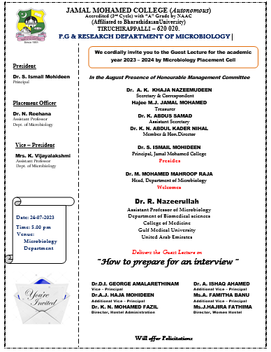

Guest Lecture Programme in Association with
Placement Cell of Microbiology 2023-2024

The Guest lecture programme of Microbiology Placement Cell for the academic year 2023 – 2024 was held on 24.07.2023 at 5:00 p.m. in Microbiology Department, Jamal Mohamed College, Trichy. The programme was started with Qirath. Dr.M.Mohamed Mahroop Raja, Head of Microbiology, welcomed the gathering and honoured the resource person Dr. R. Nazeerullah, Assistant Professor of Microbiology, Department of Biomedical sciences, College of Medicine, Gulf Medical University, United Arab Emirates. Ms. K. Asmaa, Secretary, II M.Sc., Microbiology introduced the chief guest. The special invitee Dr. R. Nazeerullah has delivered the lecture on the topic “How to prepare for an interview”. He focused on the importance of key responsibilities and requirements of understanding student’s strengths and weaknesses. He also shared his views on the various interview formats such as phone interviews, video interviews and panel interviews. The lecture was really useful for the students. The vote of thanks was proposed by Dr.N.Reehana, Microbiology department Placement officer. Totally 80 students were participated from the Microbiology department. This program is featured with a wide knowledge of sharing the expertise in preparing for a job interview to increase the chances of success.

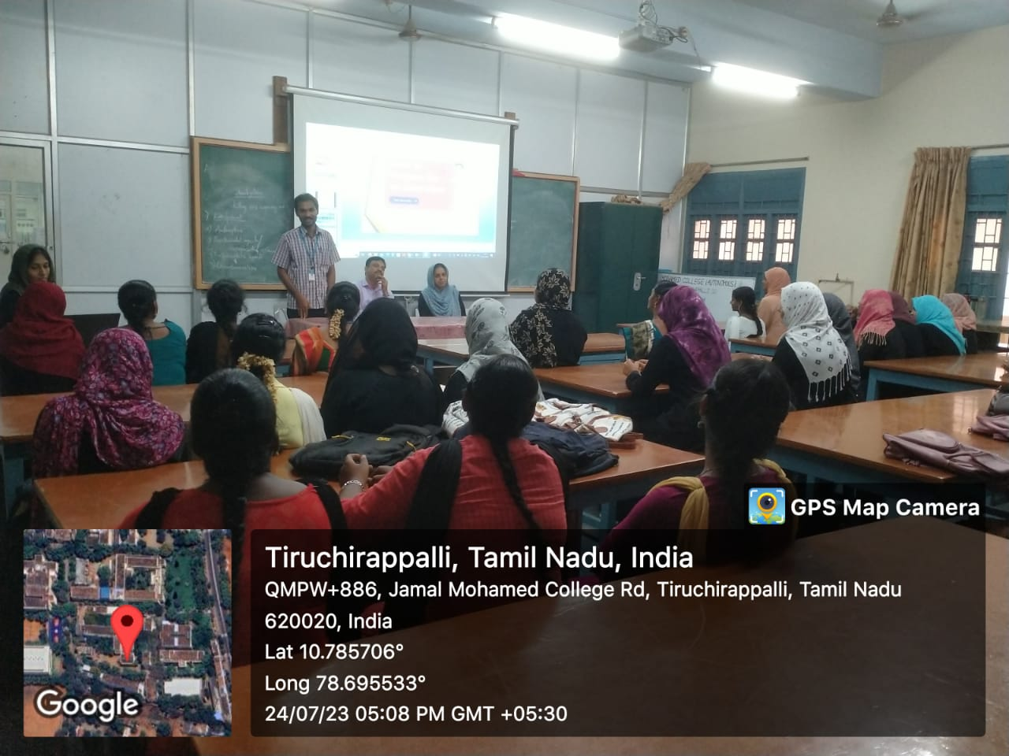

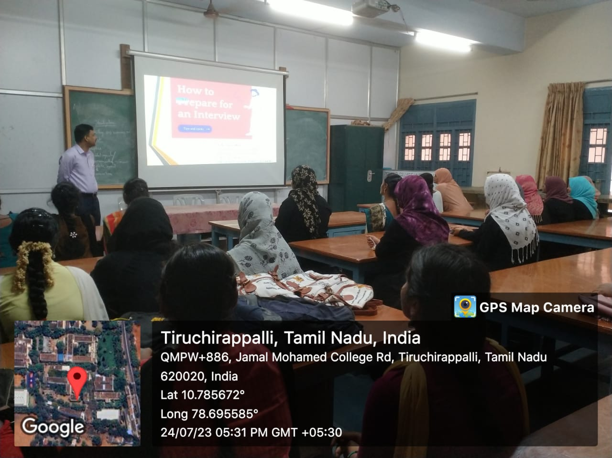
Dr.M.Mohamed Mahroop Raja, Head of Microbiology welcomed the gathering

Dr. R. Nazeerullah, Assistant Professor of Microbiology, Department of Biomedical sciences, College of Medicine, Gulf Medical University, United Arab Emirates delivered the Guest Lecture on “How to prepare for an interview”

